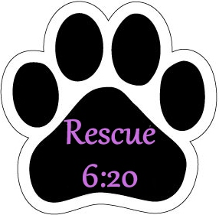
Adoption Application

Name:
Birth Date:
E-mail:
Address:
City:
State:
Zip Code:
Day Phone:
Cell Phone:
Vet Name:
Vet Phone:
Vet Records are under the name of:
Please provide 2 references (no family members)
Name:
Phone:
Relationship:
Name:
Phone:
Relationship:

Employment
Occupation:
Employer:
Phone:
Address:

Spouse's Occupation:
Spouse's Employer:
Phone:
Address:

Household Information

Do you own or rent your home?:
Are you moving in the near future?:
If so, please explain:
If you rent, you MUST provide your landlord's contact information for verification:
Landlord Name:
Phone:

List below all of the people who currently live at this residence:
Name:
Age:
Name:
Age:
Name:
Age:
Name:
Age:
Name:
Age:
Name:
Age:

Does anyone in your home have allergies to dogs?

Animals Currently Risiding in the Home:
Name:
Breed:
Sex:
Age:
Spayed/Neutered?

Name:
Breed:
Sex:
Age:
Spayed/Neutered?

What kind of food do you feed your pets?:
Have you ever owned a dog before?:
If yes, please explain what happened to it:

If your last dog died, please state the dog's name and date deceased:

Have you ever taken one of your pets to a shelter?:
If yes, please describe the circumstances:

Care of the Dog
Do you have a fenced area on your property?:
Is the area completely fenced?: If so: The fence is: feet high and the inside area is: square feet What type of fence do you have?:
If you have no fence, how do you plan to have your new dog relieve/exercise itself?:

How Active is your lifestyle aside from work? Please explain:

Do all adults in the household work fulltime?:
How many hours each day will your new dog be alone?:
How many hours each day will you spend time with your new dog?:
Where will your new dog be kept when it is alone?:
Where will your new dog sleep?:
What sort of training do you plan on providing your new dog?:

Why have you chosen to get a dog through Rescue?:

Are you agreeable to having a home-check done prior to adoption?:
What would you do if you could not keep the dog?:

How far are you willing to drive to meet a potential adoptee?:

Is there anything else you would like to add?:

